DSA0601 – DATA HANDLING AND VISUALIZATION
ACTIVITY -3
192524070 – EDDU SUCHIER

Visualization Activities with Datasets

Activity 1: Heatmap – Student Performance Analysis
Student | Mathematics | Physics | Chemistry | Programming | English
S1 | 92 | 88 | 84 | 95 | 81
S2 | 76 | 72 | 69 | 80 | 74
S3 | 81 | 78 | 83 | 85 | 79
S4 | 65 | 70 | 68 | 72 | 75
S5 | 90 | 94 | 91 | 96 | 89
S6 | 58 | 62 | 60 | 65 | 70
S7 | 84 | 86 | 82 | 88 | 80
S8 | 71 | 75 | 73 | 77 | 72
S9 | 95 | 91 | 93 | 98 | 94
S10 | 79 | 81 | 77 | 83 | 78

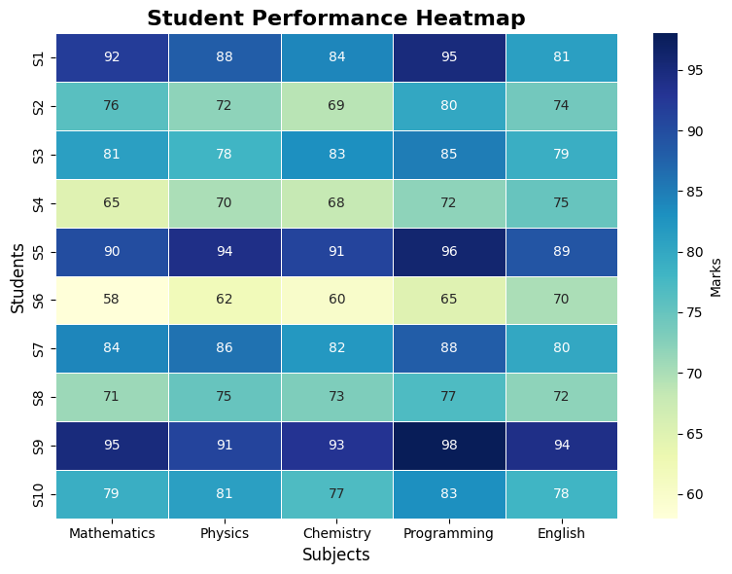
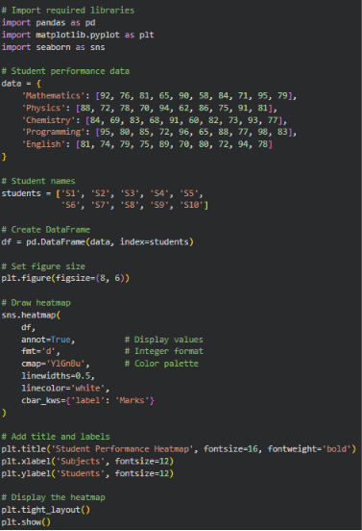
1.

2. Highest Overall Performer: S9 (Average = 94.2)
3. Highest Average Subject: Programming (Average = 83.9)
4. S6 (Average = 63.0) – Needs support in all subjects.
5. Clearly highlights high and low scores using colours.
Makes it easy to compare students and subjects.
Helps teachers quickly identify top performers and students needing support.
Reveals subject-wise performance trends.

Activity 2: Violin Plot & Boxplot – Employee Salary Analysis
Employee | HR | IT | Finance | Marketing
E1 | 4.2 | 6.5 | 5.8 | 5.1
E2 | 4.5 | 7.0 | 6.2 | 5.3
E3 | 4.7 | 7.4 | 6.0 | 5.5
E4 | 4.1 | 6.8 | 5.9 | 5.4
E5 | 4.6 | 8.2 | 6.7 | 5.8
E6 | 4.3 | 7.6 | 6.4 | 5.6
E7 | 4.8 | 8.5 | 6.9 | 5.9
E8 | 4.4 | 7.1 | 6.1 | 5.2
E9 | 4.9 | 8.8 | 7.2 | 6.0
E10 | 4.5 | 7.3 | 6.3 | 5.4

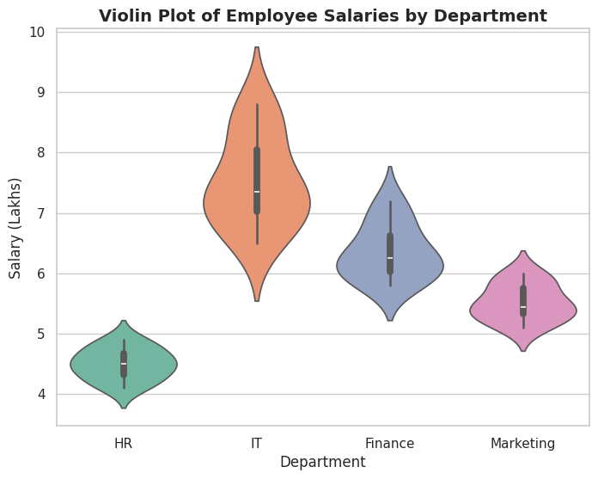
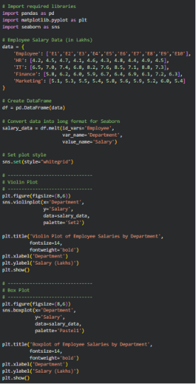
1.

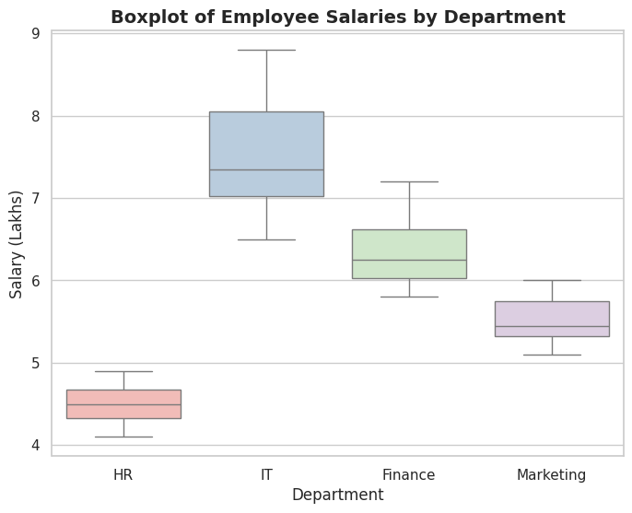
2.

3. IT has the largest variation.
4. IT has the highest median salary.
5. The Violin Plot better represents the overall distribution.

Activity 3: Histogram & Density Plot – Website Response Time
Obs | Response Time (ms)
1 | 210
2 | 225
3 | 230
4 | 240
5 | 250
6 | 260
7 | 270
8 | 280
9 | 285
10 | 290
11 | 300
12 | 305
13 | 310
14 | 315
15 | 320
16 | 330
17 | 340
18 | 350
19 | 360
20 | 380
Questions:
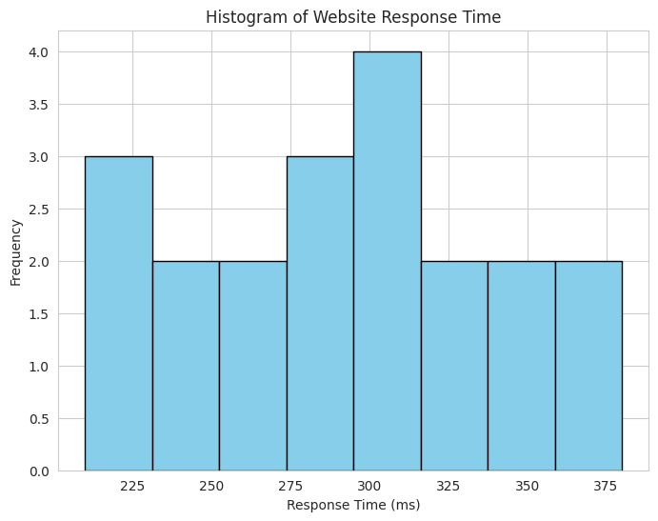
1. 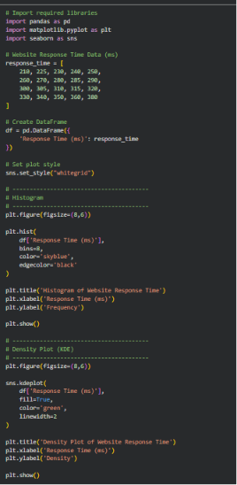
2. 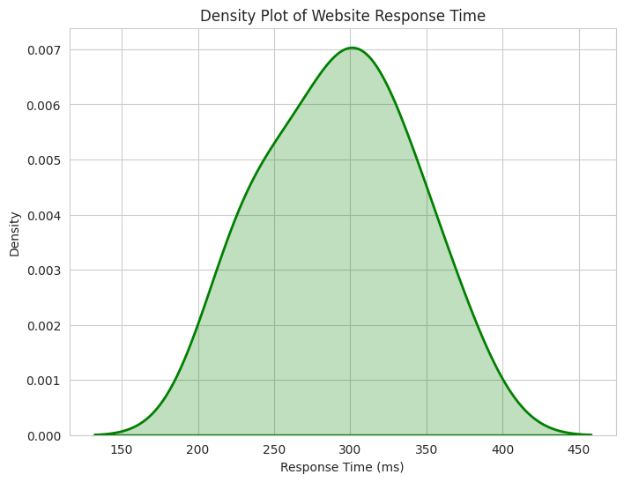
3. The distribution is slightly positively (right) skewed, as the tail extends toward higher response times.
4. The common range of website response times is 250–330 ms.
5. The Density Plot better represents the distribution because it clearly shows the overall shape and skewness of the response time data. However, the Histogram is better for displaying the actual frequencies of observations.

Activity 4: Ridgeline Plot – Electricity Consumption
House | Jan | Feb | Mar | Apr | May
H1 | 220 | 235 | 250 | 275 | 295
H2 | 240 | 245 | 260 | 285 | 305
H3 | 230 | 238 | 255 | 280 | 300
H4 | 215 | 228 | 248 | 270 | 292
H5 | 225 | 240 | 258 | 282 | 298
H6 | 245 | 250 | 265 | 290 | 310
H7 | 235 | 242 | 259 | 284 | 302
H8 | 228 | 236 | 252 | 278 | 297
H9 | 238 | 246 | 262 | 287 | 307
H10 | 232 | 239 | 256 | 281 | 301
Questions:
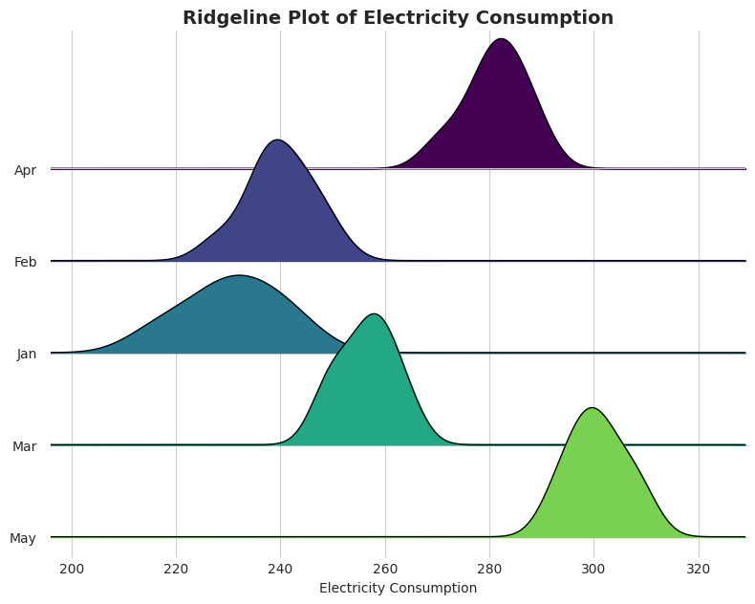
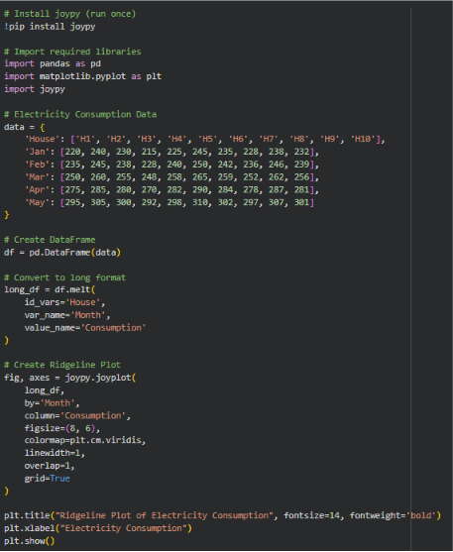
1.

2. May has the highest average electricity consumption (300.7 units).
3. January has the widest spread with a range of 30 units.
4. There is a steady increasing trend in electricity consumption from January to May.
5. A ridgeline plot effectively compares the distribution and trends of electricity consumption across multiple months in a single visualization.

Activity 5: Histogram, Density & Boxplot – Daily Steps
Person | 20–30 | 31–45 | 46–60
P1 | 9500 | 8200 | 6500
P2 | 10200 | 8600 | 6700
P3 | 9800 | 8400 | 6900
P4 | 11000 | 9000 | 7200
P5 | 10500 | 8900 | 7000
P6 | 9700 | 8500 | 6800
P7 | 10100 | 8700 | 7100
P8 | 10800 | 9100 | 7300
P9 | 11200 | 9200 | 7400
P10 | 9900 | 8600 | 6950
Questions:
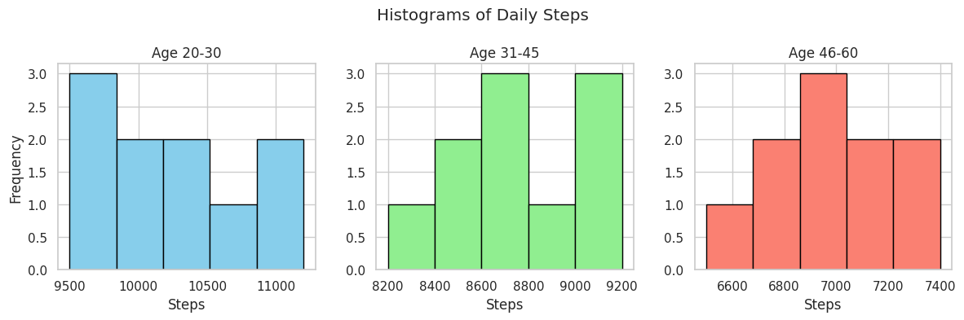
1. 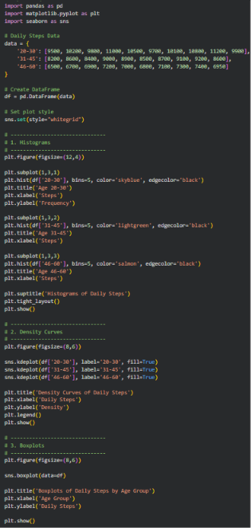
2. 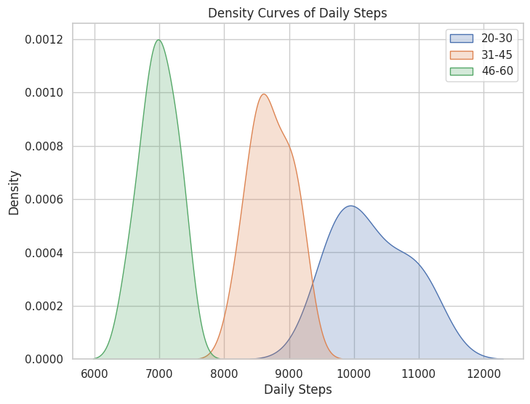
3. 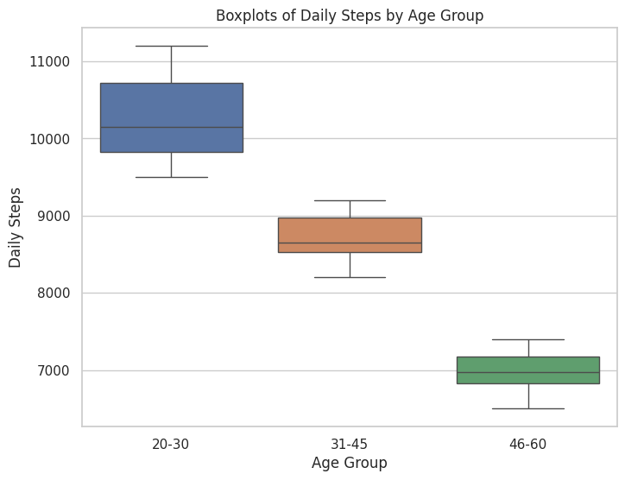
4. The 20–30 age group has the highest median daily steps, with a median of 10,150 steps.
5. The boxplot is the best visualization because it clearly compares the median, spread, and potential outliers of daily steps across the three age groups.

